So here it is. The finished circuit, now with an Arduino-compatible microcontroller.
(show finished circuit)
Let’s talk about microcontrollers.
This is the one Grandpa gave me. (sketch)
It’s an Arduino-compatible microcontroller based on the Arduino Uno.
You say it like this: Are – Du – Eee – No.
It’s an Italian word.
A microcontroller is a miniature computer that does a specific job within a larger machine or system. Microcontrollers are everywhere these days. All the so-called “smart” devices in our lives are smart because of these miniature computers inside of them.
In 2005, an Italian company named Arduino started making an inexpensive, multi-purpose microcontroller that anyone could use to build anything they wanted to build, and in 2010, they introduced the Arduino Uno, which became their most popular design for a long time after that.
Even today, all these years later, the Arduino Uno is still widely used by makers all over the world whenever they want to build something cool that needs a little electronic brain inside of it.
Like, say, a robot.
And a really awesome thing that Arduino did with their microcontrollers: they made them open source, which means they allowed anyone who wanted to copy the design and build their own, which ensured that Arduino-style microcontrollers were widely available everywhere and always nice and cheap. Today, if you’re using a microcontroller that’s built by Arduino, we typically call it an Arduino. If it was made by someone else using Arduino’s open-source design, we call it Arduino-compatible.
Open source is a pretty awesome thing, and because of it, quietly, there are Arduinos and Arduino-compatible devices everywhere making our lives easier and more fun. Scientists and engineers use them in prototypes of electronic builds. Tinkerers use them to make their own robotic devices and smart devices. Teachers use them all the time to teach the basics of electronics, robotics, and embedded systems.
And it’s super common for big companies to build first-draft prototypes with Arduinos and then, when they build the final product, to create their own microcontroller that perfectly fits the system they’re making.
I learned all of this over time. On that first day when Grandpa showed me how to make an LED blink using an Arduino, I didn’t know any of it yet.
All I knew is what Grandpa taught me.
“The first thing we need to do is download the Arduino I.D.E. from the Arduino web site,” he said.
IDE stands for Integrated Development Environment — a fancy way of saying ‘a program for writing computer programs.’ You’ll see it written like this: Arduino IDE. But say each letter: Arduino I – D – E. Don’t say Arduino I’d. In fact, if you hear someone say I’d rather than saying every letter (I – D – E), it is your job as a programmer to immediately say back to them “I’d like an egg salad sandwich.”
To download the Arduino IDE, you must go to the Arduino web site. Go to arduino.cc and navigate to products then software.
This is the web site I brought up. Note the address:
(screenshot https://www.arduino.cc/en/software/)
Then you download and install the Arduino IDE.
Grandpa and I installed the software on my laptop. It only took a minute. Then we opened it. It looked like this:
(screenshot Arduino IDE first screen)
“When you built the circuit the first time, you had a battery power the LED,” Grandpa said. “But now the microcontroller is going to power it.”
“So it works like a battery?” I asked.
“For this first circuit, you’ll have the microcontroller plugged into your computer. Your computer will power the microcontroller and it will power your circuit.”
I looked again at my circuit on the breadboard. All it needed was power (show sketch).
“We have to program the microcontroller to send pulses of electricity, on and off, so the LED blinks,” Grandpa said. “I’ll help you write the code.”
I’m going to show you the exact program Grandpa and I wrote that day. You’ll have to open the Arduino IDE and make the screen look exactly like mine.
I’m only going to show you the correct program, but you should know that I made a lot of mistakes before I got it right. It’s ok if you make mistakes too. The software will tell you that you did. You’ll see.
For now, just type in the code, and as you do, see if can figure out what might be going on. We’ll talk about the code in-depth in the next chapter.
Here’s the code we wrote:
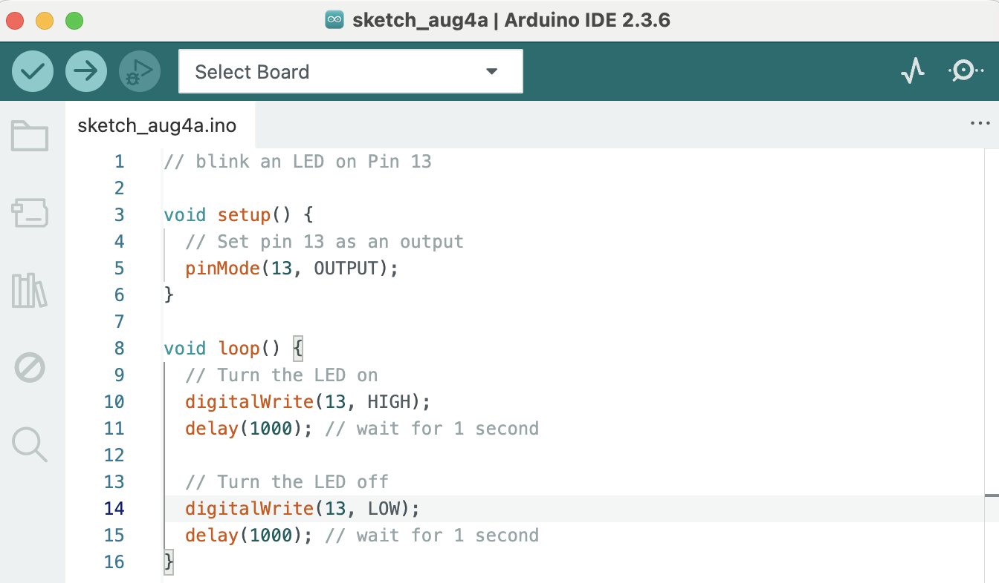
“Alright, I’ve typed it in,” I said. “Now what?”
“Now we have to load the code onto the microcontroller,” said Grandpa.
As you may have already guessed, we can connect the microcontroller to the computer using a USB cable, like this:
(show sketch)
We connected our microcontroller.
“Click the Select Board dropdown,” said Grandpa.
I clicked it and saw our board listed — on yours it’s probably something like ‘Arduino Uno’ or ‘COM3’. We selected it.
(show screenshot)
You’ve seen that there are two buttons on the top left of the window for the Arduino IDE. One is a checkmark, and one is an arrow. If you hover your mouse over them, they tell you what they are.
(show screenshot and captions)
Click the Check Mark. This checks your code for typos and formatting errors. If all is well, you’ll see this:
(show screenshot)
Note: if you got some kind of error at this point, congratulations! You’re a real programmer now! Programming is all about fixing errors. See if you can figure out where you went wrong. If you’re totally stuck, fear not. I’ll have all sorts of hint and help for you in the next chapter.
One more step needed to load the program on the microcontroller. Take a guess what it is.
Right! We need to press the arrow button.
(show screenshot)
Do you notice something happening that maybe wasn’t happening before?

For me, the programming didn’t come easy. In fact, writing that first program for the Arduino wasn’t one of those movie montages where the hacker hero types fast and yells, ‘I’m in!’ It was three hours that evening of trial, error, and me wondering why my LED refused to blink.
Here’s the code I wrote.
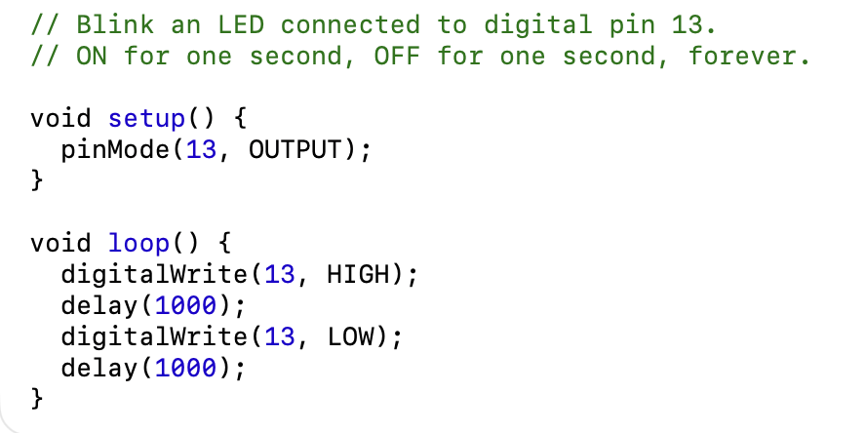
I wish I could tell you I wrote that code from scratch and am well on my way to being a master programmer who makes microcontrollers kneel before my will.
Except I copied that code, line by line, from Sparky McVoltage, author of Simple Robots for Clever Humans.
He put that code in Chapter 3 of his book. In the chapter, he also explained, step by step, how to hook up the Arduino to the computer, how to download the coding software, how to upload the code…
It turned out he even had a web site with videos on how all this works. His videos are funny. Whoever he is (he never seems to show his face), he teaches Arduino like he’s narrating a heist move.
Are you building along with me as you read? You should be. If you want to build this circuit, make it work, and understand all the code, I need you to now go to Sparky McVoltage’s web page:
www.sparkymcvoltage.com
Find the lesson called “Chapter 3: Your First Arduino Build.”
You can follow the QR code in the margin to go straight to the web site.
Don’t worry, I’ll still explain the important parts here.
To start, you need an Arduino-compatible microcontroller. Here’s mine (sketch of Arduino Uno).
You’ll also need a USB cable to connect to your computer (sketch)
On your computer, you’ll need to download the Arduino software.

In fact, let’s go through that whole program.
This program is written in a language called C++. (ChatGPT – it’s the Arduino programming language which is a subset of C++, right? I want to be correct but I don’t want to be burdensome. I could use a footnote if needed. Can I just call it C++?)
Here’s the first part of the code:
// Blink an LED connected to digital pin 13.

These are called comments. In the Arduino programming language, when you type two backslashes like this:
//
you’re telling the computer, “The rest of this line is a note for me and anyone else reading the code.”
So we type:
// Blink an LED connected to digital pin 13
as a kind of title to the code so anyone reading knows what this program is,
Then we say:
// ON for one second, OFF for one second, forever.
to explain exactly what this program does.

Then we get into the actual code.
void setup() {
pinMode(13, OUTPUT);
}
That block tells the Arduino to set up Pin 13 as an Output pin, meaning any wire pluged into Pin 13 is going to have an electrical signal come from the Arduino and out through the wire to whatever’s connected.

Now we’re into the heart of it.
void loop() {
digitalWrite(13, HIGH);
delay(1000);
digitalWrite(13, LOW);
delay(1000);
}

That is the program. It’s a loop because it runs over and over again.
digitalWrite is called a function, and first it tells Pin 13 to turn on, or send a HIGH electrical signal. Then the delay function has the program wait for 1000 milliseconds before moving to the next line. Then digitalWrite again, only now Pin 13 is turning off, or having a LOW electrical signal. Another 1000 milliseconds of delay finishes the loop, and then the loop starts again, over and over, for as long as the Arduino stays powered on.
In other words, this program turns an electrical current, outputting from Pin 13, on and off again, with 1000 milliseconds (or 1 second) in between each blink.
And voila! You have a blinking LED!
(sketch of blinking LED on breadboard)

When it finally worked, I just sat there for a minute, getting hypnotized by the blinking light. After all those trial runs and wrong wires and mystery errors, it was alive. Just a pulse of light, steady and patient, like a heartbeat from the circuit itself.
But Marvin didn’t just want us to make one blinking LED. He wanted us to build The Beacon of Orinthgloth, which had three LEDs, one blue, one red, one yellow.
I was pretty sure I knew how to do that now. Seems easy, right? Just add more LEDs to the breadboard and write more code to make them blink.
Except Marvin wanted them to blink in The Sequence of Rumradikan.
And he never told us what that even meant.
That night I kept thinking about it. What is The Sequence of Rumradikan? I wondered if there was another clue somewhere we were meant to find. I wondered

, I kept thinking about it. Then school happened. Homework, basketball, WOMP auditions coming up. And slowly, without really deciding to, I stopped thinking about the beacon. So did my friends. Or so I thought.

But he wanted us to make them blink in The Sequence of Rumradikan, and he never told us what that even meant.

For full step by step instructions, including instructions for different types of computers, go to gavinholloway.com/Arduino
If you’re completely “dead in the water” as Grandpa likes to say when electronics aren’t working and you have no idea why,

